# **Name: Abdurrahman Qureshi**

# **Roll No: 210451**

Practical No: 7

**1)Right angled triangle**

**CODE:**

Module Module1

Sub Main()

Dim n As Integer

n = InputBox("Enter number of rows")

Dim ch As Char

ch = InputBox("Enter your desired character")

For i As Integer = 0 To n

For j As Integer = 0 To i

Console.Write(ch)

Next

Console.WriteLine(" ")

Next

Console.ReadLine()

End Sub

End Module

**OUTPUT:**

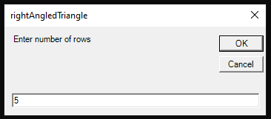

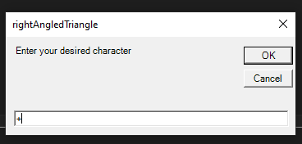

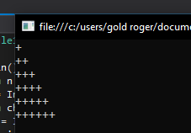

**2)Equilateral Triangle**

**CODE:**

Module Module1

Sub Main()

Dim n As Integer

n = InputBox("Enter number of rows")

For i As Integer = 1 To n

For j As Integer = 1 To n - i

Console.Write(" ")

Next

For j As Integer = 1 To i

Console.Write(" * ")

Next

Console.WriteLine(" ")

Next

Console.ReadLine()

End Sub

End Module

**OUTPUT:**

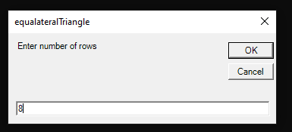

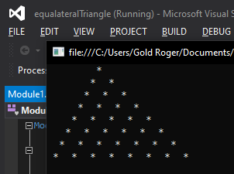

**3)Squaring an array**

**CODE:**

Module Module1

Sub Main()

Dim numArray As Integer() = {7, 3, 6, 2, 9}

Dim num As Integer

For Each num In numArray

Console.WriteLine("The square of " & num & " is " & num * num)

Next

Console.ReadLine()

End Sub

End Module

**OUTPUT:**

